1. **Agenda:**

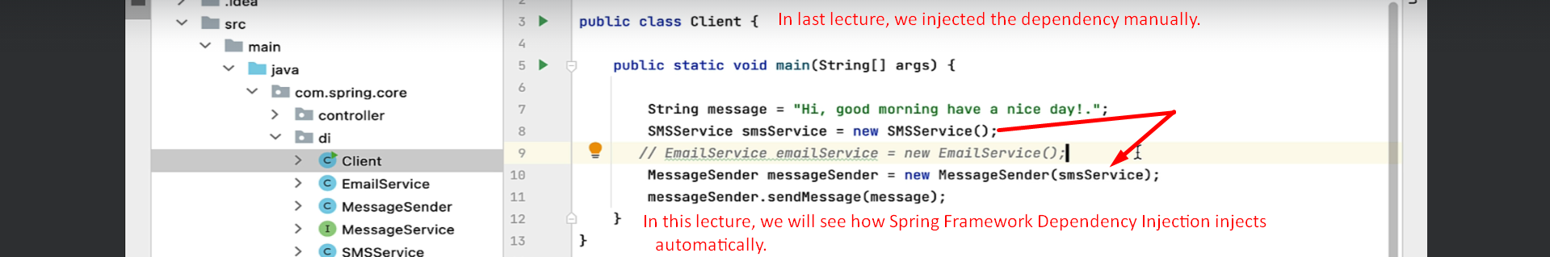

1.  **Till now, we annotated the classes with @Component which will be act as dependency.**
2. **Let’s annotate the class which requires one of the above dependencies.**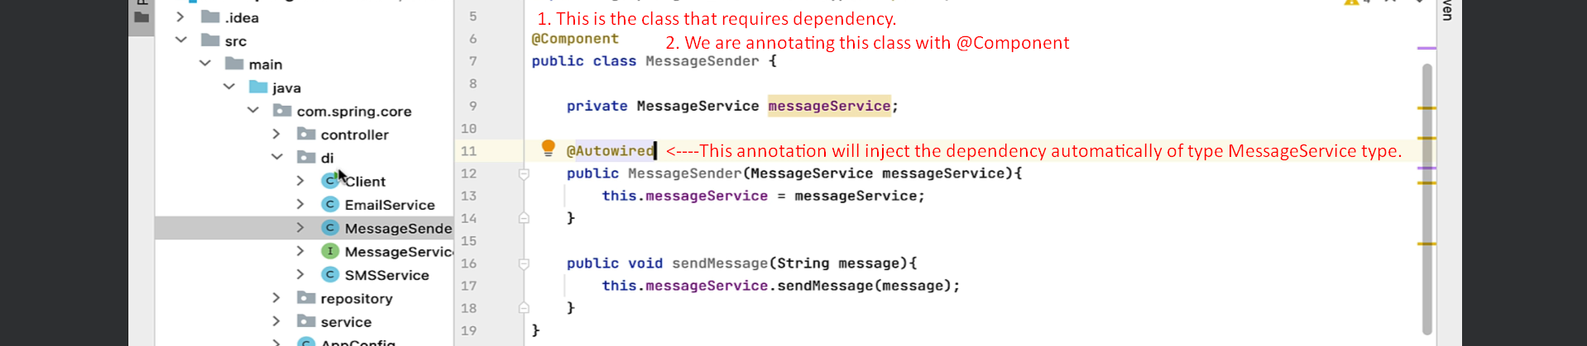
3. **As we are using annotation-based configuration (@Component, @Autowire), so we need to tell the package to be scanned.**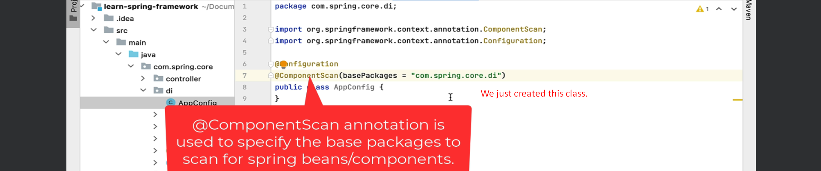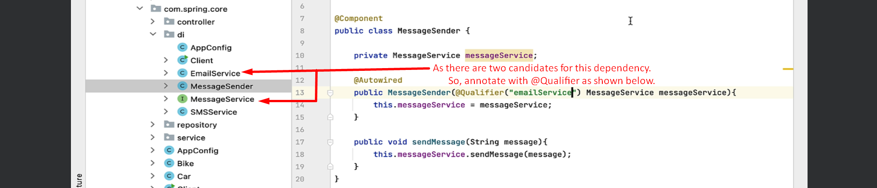
4. **Let’s test all the changes.**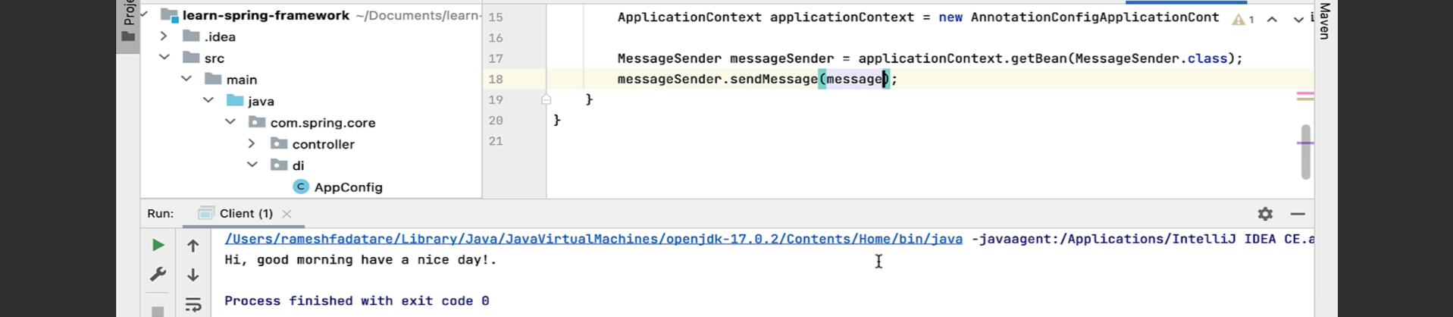
5. **Observations:**
   1. We did not create any object (**@Component worked here**).
   2. We did not inject dependency (**@Autowired worked here**).
   3. In order the above annotations to work, we require **@Configuration @ComponentScan(basePackages=”package-name”)**
6. 